*Apis Insight for Phenotype Classification and Hive Health Forecasting using IoT and Deep Learning*

Arulmurugan. A  
*Dept. of Computing technologies School of Computing*  
*SRM Institute of Science and Technology*Kattankulathur, India  
arulmural@srmist.edu.in

Tanya Singh  
*Dept. of Computing technologies School of Computing*  
*SRM Institute of Science and Technology*Kattankulathur, India  
ts7307@srmist.edu.in

Ritvik Kumar Singh  
*Dept. of Computing technologies School of Computing*  
*SRM Institute of Science and Technology*Kattankulathur, India  
rs5051@srmist.edu.in

*Abstract*—This research illuminates the pivotal quandary of bee health classification native to the Indian subcontinent, a crucial facet of maintaining agroecological equilibrium. Through a multifaceted integration of advanced computer vision, intricate deep learning paradigms and hardware monitoring, the study explores the application of cutting-edge technologies to monitor and assess bee health and subspecies as well as beehive assessment. By incorporating hardware-based monitoring systems, the research exemplifies the vanguard potential of technologically entrenched methodologies in the realm of agricultural sustainability. This approach not only addresses the complexities of bee phenotype classification within the specified geographical context but also emphasizes the utilization of hardware components for real-time environmental data collection, fostering a paradigmatic shift in the axiomatic fulcrum of agro-symbiotic consilience.

Keywords— Agro-symbiotic Consilience, Hardware Monitoring Systems, Computer Vision, Deep Learning, Agricultural Sustainability

# **Introduction**

Pollinators, with a focus on bees, play a crucial role in preserving agroecological balance by facilitating the pollination of flowering plants, thereby supporting agricultural productivity and biodiversity. In the Indian subcontinent, where agriculture is integral to the economy, ensuring the health and vitality of bee populations is paramount. This research initiative embarks on a multifaceted exploration, addressing key aspects: (1) The pressing challenge of bee health, (2) Subspecies identification for both commercial and research applications, (3) Beehive health assessment and real live time monitoring and, (4) Tackling the significant issue of Colony Collapse Disorder (CCD) in India. The central objective of the study being conducted is for creation of a durable model which can help with the conjecture of the health status, subspecies classification and beehive health status of individual bees. Through the convergence of technology and biology, the aim of this research is to offer a comprehensive solution that empowers beekeepers, farmers, researchers, and conservationists with real-time insights into bee populations. This, in turn, facilitates informed decision-making and timely interventions to safeguard these indispensable contributors to our ecosystem.

Safeguarding these vital contributors to our ecosystem has been a focal point of recent research endeavours, with Image Classification algorithms being increasingly employed to monitor bee health and establish beehive monitoring systems. Precision apiculture, denoted as PA, introduces a pioneering framework for the administration of apicultural settings. This methodology centres on the detailed observation of singular bee colonies as a fundamental aspect of apiary management. roach entails the systematic observation of individual bee colonies with the goal of enhancing productivity while concurrently minimizing resource utilization. It is categorised as a subfield within precision agriculture, precision apiculture aims to enhance efficiency and sustainable practices in beekeeping operations. Previous studies have explored the use the weight of hive, and further researched onto the live climatic conditions like the temperature of beehives as well as dampness inside and outside of the beehive as well as acoustic signals and flight activity around beehive in order to assess beehive status[1]. Simultaneously, various researchers have explored the utilization of imagery data and micro-climate parameters for the purpose of monitoring the health of beehives. Nevertheless, prevalent monitoring systems frequently demonstrate elevated energy demands, relying on non-rechargeable batteries that require frequent upkeep. This reliance on maintenance procedures may induce stress among bees, potentially compromising their overall well-being[2]. Moreover, remote apiaries often lack wall power connections. To overcome these challenges, there is an urgent requirement to devise a methodology capable of harnessing energy from ambient sources, proficiently managing the gathered energy, and ensuring the uninterrupted operation of monitoring systems for honeybees.

In the recent past, the rise of the field of hardware and software integration using Internet of Things (IoT) in Precision Agriculture has given rise to numerous proposals aimed at advancing the study of Precision Apiculture. These proposals vary in technical concepts and associated production costs. The proliferation of IoT systems has been accompanied by widespread availability of cost-effective Commercial Off-The-Shelf (COTS) components[1][3]. In this context, various remote monitoring systems have been suggested to alleviate the financial burden of apiary maintenance while simultaneously enhancing colony production. Furthermore, these systems facilitate extensive data collection for scientific research and investigative purposes, and making a substantial contribution to mitigating the decline in bee colonies and fostering a more profound understanding of the factors influencing beekeeping activity. [3].

Assessing the health of a beehive population necessitates an initial examination of the individual phenotype classification of bees. Recent advancements in Deep Learning (DL) and Image Processing show encouraging potential for automatically identifying bees and assessing their well-being. This includes considerations of environmental conditions such as temperature and humidity, as well as the detection of signs indicating varroa destructor infestation. Utilizing these technological progressions, the classification of a bee's health status can be accomplished through the thorough analysis of images.

In this paper, we outline our endeavours to construct a cost-effective and modular system designed for easy deployment and upgrades. Our objective is to obtain high-quality data using predominantly consumer-grade equipment. The purpose of this system is to assist beekeepers by delivering pertinent information about the condition of their bees and live beehive status using real-time monitoring [3]. Additionally, it aims to offer warnings concerning unhealthy hive activity or any unhealthy bee either through image analysis or through the identification of predetermined patterns and signatures indicative of bee health issues [1].

The subsequent sections of this paper are organized as follows: Section II presents an overview of the diverse bee species present in the Indian subcontinent. Following that, Section III elucidates the live beehive monitoring system, while Section IV delineates the data utilized for analysis. Section V expounds on the methodology employed for real-time monitoring in the study of beehives. Lastly, Section VI encapsulates the principal findings derived from this research.

# **HONEY BEE SPECIES AND BEE HIVE CLASSIFICATION**

## Dammer Bee(Tetragonula iridipennis)

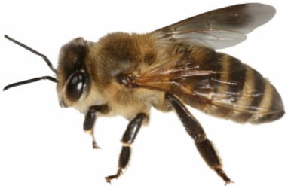The Indian stingless bee, scientifically known as Tetragonula iridipennis, is a bee species within the Apidae family and Apinae subfamily.

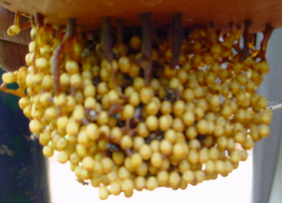

FIGURE 1: DAMMER BEE AND BEEHIVE

The Indian stingless bee, Tetragonula iridipennis, requires an optimal hive The temperature varies between thirty-four point five and thirty-five point five degrees Celsius [11].

## Italian Honey Bee

The initial introduction of domesticated honeybees to North America involved the Italian honeybee species (Apis mellifera ligustica). Known for their amiable nature and extensive distribution, these honeybees have achieved widespread prevalence, primarily due to their remarkable adaptability to diverse climates. Characterized by yellow-brown and dark brown stripes on their bodies, these bees demonstrate swift reproductive capabilities and sustain substantial colonies even in the winter months. [12].

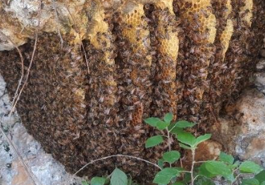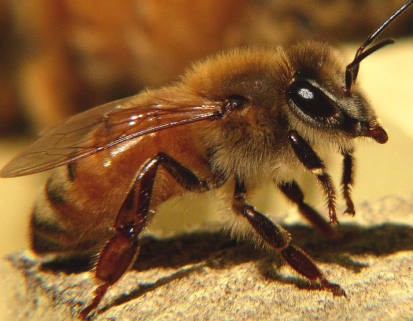

FIGURE 2: ITALIAN HONEY BEE AND BEEHIVE

Apis mellifera employs both heating and cooling behaviors to regulate the nest temperature, aiming to maintain stability close to the ideal temperature of 35°C. This encompasses a range of 32–36°C.

## VSH Italian Honey Bee

VSH, or Varroa Sensitive Hygiene, Italian bees are a type of genetically modified honeybees that allows a colony to endure without the need for mite controls. This trait induces VSH hygienic behavior, involving the removal of cells infested with mites from the brood nest. within a beehive.

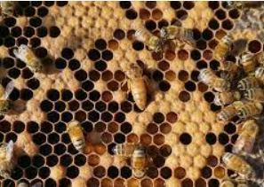

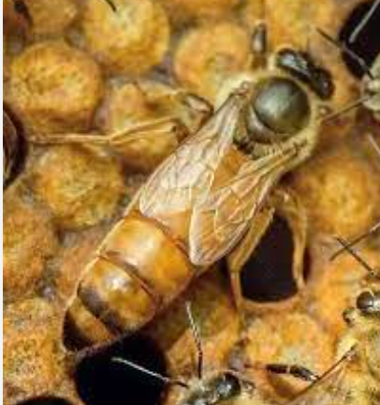

FIGURE 3: VSH ITALIAN HONEY BEE AND BEEHIVE

Honey bee hives typically maintain a temperature range between 33-36°C, coupled with an average humidity level of around 52% [13].

## Indian Hive Bee

The mentioned species is Apis cerana indica, commonly recognized as the Asiatic honey bee or Eastern honey bee. Originating in India and Asia, these bees play a crucial role in the commercial production of honey and other bee-derived products. Acknowledged for their significance as pollinators for coconut palms, these bees are prone to absconding and swarming behaviors.

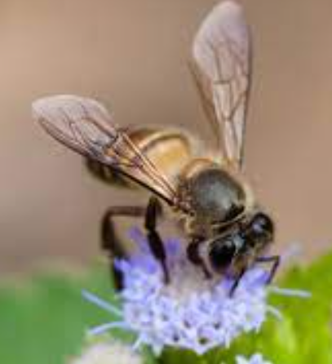 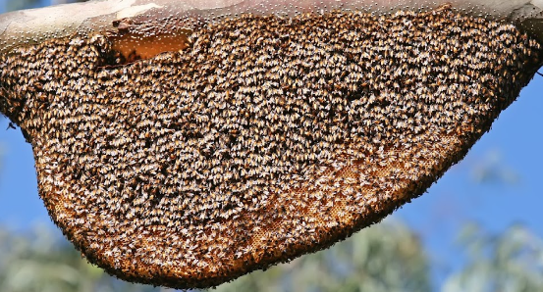

FIGURE 4: INDIAN BEE HIVE AND BEEHIVE

# **BEEHIVE MONITORING SYSTEM**

In recent years, as the global COVID-19 pandemic has disrupted the supply and logistic food chains worldwide, the agricultural sector had to face numerous problems on the worldwide level [2]. Various problems like the increase in global warming levels, climatic changes, and frequent weather disruptions and storms have added to these difficulties. Hence incorporating new real time monitoring systems and using new technological solutions, there is potential for humanity to overcome these predicaments by addressing the intricate relationships within the food-water-energy-climate nexus [4]. This opens avenues for the transformation of agriculture from traditional practices to a digital paradigm.

The real-time monitoring system employed for overseeing sensor to assess the internal conditions of the beehive. The temperature and humidity observations were captured and showcased on a 16x16 LCD display, connected to the circuit board through an I2C module. Subsequently, the recorded data was uploaded to the Arduino Uno Board for processing. After converting the binary data into numerical format, it was transmitted through the COM9 serial port connection, and the outcomes were exhibited on the Arduino Serial Port. The code for the temperature sensors utilized the Arduino DHT11 library. As an additional enhancement to the monitoring system, the data from the COM9 Serial Port was routed through the Flask module to the designed web interface, allowing the recorded values to be displayed on the website.

The comprehensive setup involves a range of key components, including a DHT11 sensor, a 16x16 LCD display module, an I2C module, a 220 Ohm ¼ Watt resistor, an electronic breadboard, an Arduino UNO Board, B10 Buzzers, and carefully connected jumper cables. The diligent DHT11 sensor continuously monitors the intricate balance of temperature and humidity conditions within the beehive. In the event of substantial temperature and humidity fluctuations, the sensor promptly triggers buzzer warnings, ensuring swift alerts to both vigilant beekeepers and dedicated researchers. Leveraging the COM9 serial port, the recorded data seamlessly makes its way to the serial monitor, providing a comprehensive display for in-depth analysis and continuous observation.

An essential advantage of monitoring beehives lies in the timely identification of potential issues. Instances like abrupt fluctuations in temperature or humidity signal potential stress within the hive, enabling swift intervention to pinpoint and resolve underlying problems like diseases or pest infestations [5]. Monitoring the hive's weight is a crucial aspect of beekeeping that offers valuable insights into honey production cycles. By regularly assessing the hive's weight, beekeepers can effectively gauge the colony's productivity and health. This practice becomes particularly significant in determining the opportune moment for harvesting honey, striking a balance between maximizing yield for beekeepers and ensuring there is a sufficient honey reserve left for the sustenance of the hive. The precision in timing that comes from monitoring hive weight contributes to the overall well-being of the bee colony and supports sustainable beekeeping practices. This approach aligns with the principles of responsible hive management, ensuring both the welfare of the bees and the efficiency of honey extraction processes.

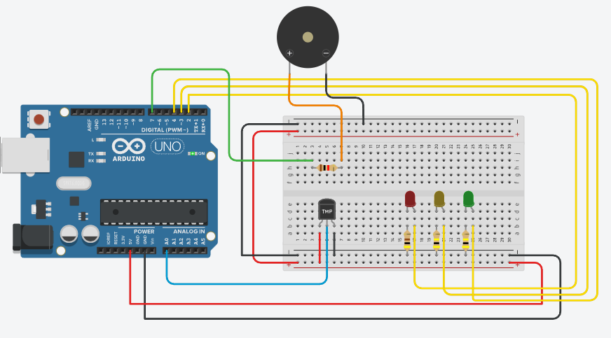

FIGURE 5: LIVE MONITORING

This above framework is based on Real live-time Performance Monitoring of the beehive. This involves the regular collection of live beehive conditions data to create a record of status of a bee colony at any moment. Performance monitoring abstains from drawing conclusions or offering interpretations of the monitored data. The responsibility for making inferences about hive health is delegated to the end-user.

* Temperature: The reproductive process of honeybees requires a consistent and moderate air temperature within the hive, ideally ranging between 14.28 and 36.5ºC. To sustain right environmental conditions inside the hives, bees utilize adaptive techniques. In cases of lower temperatures, they produce metabolic warmth by clustering together [6][7]. Conversely, in the case of elevated temperatures, they transport water into the hive, thereby augmenting humidity.
* Humidity: Assessing the relative humidity within beehives stands as a crucial factor in gauging the condition of colonies and plays a direct role in influencing productivity [7]. Existing studies affirm that temperature and humidity levels exhibit variations based on the subspecies of bees. Maintaining a relative humidity within the hive ranging from 90% to 95% is essential for optimizing the hatching of eggs.

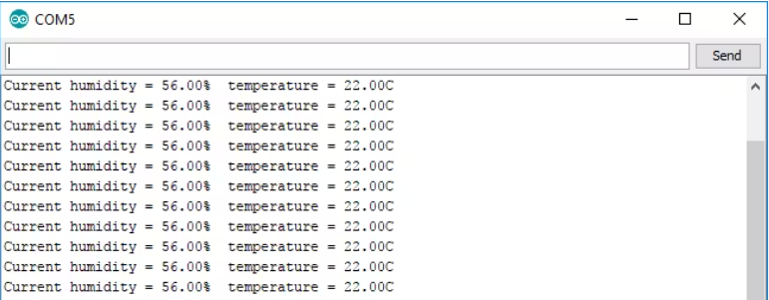

FIGURE 6: SERIAL MONITOR OUTPUT

# **DATA DESCRIPTION**

This section delves into the comprehensive examination of multiple attributes essential for mapping and providing an in-depth analysis of Bee phenotype classification. The dataset under consideration encompasses 1795 images, showcasing diverse Indian bee subspecies, including the Dammer bee, Italian bee, VSH Italian bee, and Indian hive bee. The data collection and comparisons primarily originate from various locations such as Kalakadu, Nedumangad, Almora, Bela Greya, and Alchuna.

Moreover, for reference and sub-species comparison, we have utilized the BeeImage Dataset: Annotated Honey Bee Images [8]. This dataset serves as a valuable resource in augmenting our understanding and analysis of different bee subspecies.

## Healthy Status Categorization

For classification of the heath status of the bee which involves an image dataset, the data comprises cropped images of honey bees, each associated with various attributes. These attributes signify the current health status of the beehive

the honey bee's subspecies and its current involvement in pollination. In the development of the classifier, emphasis was placed on the health attribute, serving as a direct indicator of the bee's well-being [6]. Moreover, classifier development took into account distinct aspects, including the attributes related to subspecies and the transportation of pollen, as they contribute to a more nuanced understanding of hive health. Examining the pollen carrying attribute, for instance, allows for assessing the availability of food supplies by counting the number of bees transporting pollen [3]. Meanwhile, subspecies information aids in identifying potential hive robbing instances, where bees from another hive, possibly of a different species, invade for nectar and honey collection. These attributes collectively demonstrate their potential in contributing to the classification of bee health [2]. Furthermore, the aspect of pollen carrying can be further be studied to specify the type of pollen that is optimal for the beehive to transport.

## Subspecies Classification

In the context of subspecies classification, the various Indian subspecies like (Trigona iridipennis) Dammer bee, (Apis Mellifera) Italian bee, VSH Italian Honey Bee, and (Apis cerana indica) Indian Hive bee were considered. The subspecies classification in this research is accomplished through a well-designed deep learning model. Leveraging Convolutional Neural Networks (CNNs), the model processes intricate visual patterns and distinctive features present in bee images to classify them into distinct subspecies. Through convolutional layers, the network learns hierarchical representations of the input data, enabling it to discern subtle differences in morphology and coloration that characterize various bee subspecies [9]. The utilization of deep learning techniques facilitates automated and accurate subspecies identification, contributing to the broader understanding of bee biodiversity. This approach not only streamlines the classification process but also establishes a foundation for monitoring and preserving diverse bee populations, thereby fostering sustainable agricultural practices and environmental conservation [5].

## Pollen Classification

The act of pollination holds a crucial function as a regulatory ecosystem service in the natural environment. Within the realm of insect pollinators, the predominant contributors to pollination in both managed and natural ecosystems are solitary and social bees.

The major pollinating plants recognized for various bee species are:

* Dammer bee: This bee primarily visits crops exhibiting extensive blooming patterns, such as coffee, guava, mango, and Eucalyptus with Eucalyptus being the primary seed being pollinated [10].
* Italian honey bee: This bee visits crops like Mustard, Sunflower, Cotton, and Apple.
* VSH Italian honey bee: This bee is genetically modified version of Italian bee with resistance against Varroa Mites and primarily pollinates Sunflower and Mustard.
* Indian hive bee: This bee primarily pollinates Turnip, melon, pumpkin, radish, and coriander.

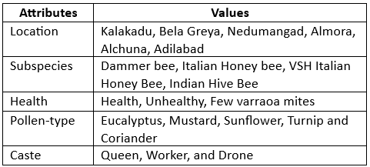TABLE 1: ATTRIBUTES CLASSIFICATION

Table 1 provides a comprehensive depiction of the various values (classes) corresponding to each attribute within the dataset problem. It is worth noting that specific attributes, particularly subspecies, are allocated for instances where examples remain unidentified. The meticulous annotation of the health attribute was carried out by seasoned field experts during the image capture of honey bees, ensuring the accuracy and reliability of the dataset.

Furthermore, the health attribute extends its coverage to encompass hive-related issues, offering detailed categorizations such as "Healthy," "Unhealthy," and "few varroa mites." This nuanced classification provides a more intricate understanding of the well-being status of honey bees data in the dataset. Additionally, the dataset incorporates information about the type of pollen, a crucial element for determining the optimal crop selection in the nearby vicinity of the beehive to facilitate optimal cross-pollination. This deliberate inclusion holds significance as it recognizes that changes in the beehive's condition can serve as indicators of alterations in honey bees and vice versa, creating a robust and interconnected dataset for analysis and classification purposes.

# **PROPOSED METHODOLGY**

The goal of the Model was to correctly assess the bee health and subspecies based on the variety of attributes. For comparison with other models 2 models were narrowed down for the bee image processing to correctly determine the correct bee phenotype. In the provided code, a convolutional neural network (CNN) based on the MobileNetV2 architecture is used for bee health classification. The MobileNetV2 is designed for mobile and embedded vision applications, it is a lightweight and efficient deep learning model which was proposed for use in remote environments, where most of beehives and apiaries are located. It is an extension of the original MobileNet architecture, incorporating inverted residual blocks with linear bottlenecks to enhance feature extraction while maintaining computational efficiency. During the implementation phase, many challenges were encountered with suboptimal model performance metrics, prompting iterative adjustments to enhance the overall system. Initially utilizing a Sequential Model, we transitioned to a transfer learning approach, employing the MobileNetV2 architecture for improved feature extraction [15]. Methods for augmenting data were employed for addressing limited training data, and the model underwent fine-tuning to enhance performance. The model architecture was serialized into a JSON file, and class labels were saved separately for reproducibility. These modifications, guided by experimentation and evaluation metrics, ultimately culminated in an enhanced system poised for reliable and accurate bee health assessment, showcasing the adaptability and resilience of the proposed method.

For improving the model’s accuracy and F1 score, several strategic modifications were implemented. Initially, the Sequential Model architecture was replaced with the more sophisticated MobileNetV2, a transfer learning approach known for exceptional attribute extraction capabilities. By leveraging the pre-trained weights from the provided dataset, the model gained a nuanced understanding of intricate features within bee images, contributing to improved classification accuracy. Methods for augmenting data were implemented during the training phase to artificially diversify the dataset, reducing and mitigating overfitting while improving the model's ability to generalize to unseen data.. Additionally, hyperparameters were fine-tuned, including adjustments to learning rates and the introduction of dropout layers to mitigate potential overfitting. The implementation of early stopping and model checkpoint callbacks ensured the model's training was optimized, preventing unnecessary epochs and preserving the best-performing model. Serialization of the model architecture into a JSON file and saving class labels separately streamlined reproducibility and model deployment. These collective modifications reflect a systematic and iterative approach aimed at refining the deep learning model, resulting in a significant improvement in accuracy and F1 score for robust bee health assessment.

* Learning Rate: The learning rate is implicitly set by the Adam optimizer.
* Epochs: The training process is configured to run for a maximum of 200 epochs, determining the number of passes the model makes through the entire training dataset.
* Batch Size: A batch size of 256 is specified, defining the number of training examples utilized in one iteration during the model training process.

The optimization process, the learning rate of the model, and the effectiveness of training are significantly impacted by these hyperparameters. They play a crucial role in controlling the performance of the deep learning model. The layers employed in the model include:

* MobileNetV2 Base Model: MobileNetV2 is used as the base model, a pre-trained convolutional neural network (CNN) with efficient inverted residual blocks for feature extraction in image classification.
* Global Mean Pooling Layer: The integration of a Global Mean Pooling layer involves the spatial averaging of feature maps obtained from the base model, leading to the reduction of their dimensions to a singular value per channel to facilitate information aggregation.
* Dense Layer with SoftMax Activation: The dense fully connected layer serves as the output layer with neurons equal to the number of classes. SoftMax activation produces probability distributions for multi-class classification, determining the predicted bee health category.

TABLE 2: PERFORMANCE METRICS

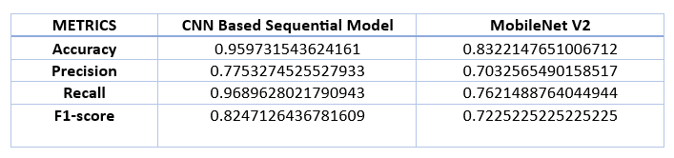

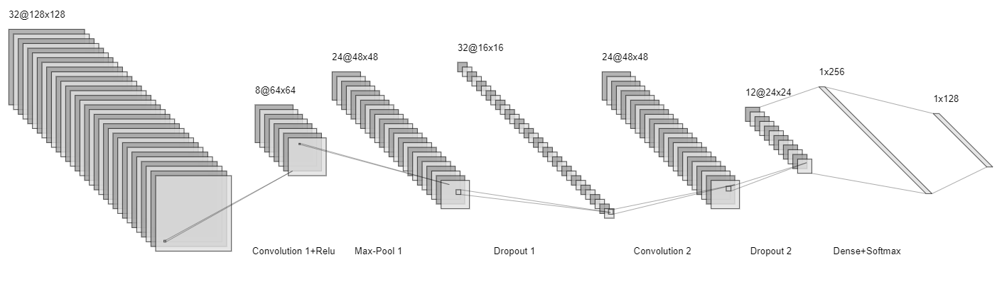

FIGURE 7: MODEL AECHITECTURE

Furthermore, the original Sequential model is a conventional deep learning architecture where layers are added sequentially. It requires manual configuration of layers, which can be time-consuming and may not be optimized for specific tasks. The layers used for classification were Convolution, Max Pooling, Dropout1, Convolution, Dropout 2, Dense layer with SoftMax activation [14]. The Sequential Model may be suitable for general image classification tasks but may lack the efficiency needed for real-time applications on resource-constrained devices while, the MobileNet V2 is well-suited for the bee health assessment project as it balances accuracy and computational efficiency and is especially useful for edge computing scenarios, such as on-site bee health monitoring, due to its lightweight design.

# **CONCLUSION**

In conclusion, the bee phenotype assessment project represents a multifaceted approach leveraging cutting-edge technologies to monitor and evaluate the well-being of bee colonies. Through the integration of image processing, deep learning, and real-time environmental sensing with Arduino modules, our system provides a comprehensive analysis of both individual bee health and overall hive conditions.

The implementation of various models like CNN (Based on Sequential Architecture), MobileNetV2-based deep learning model for bee health classification demonstrates the project's commitment to accuracy and efficiency in image analysis. Despite challenges in optimizing the model, iterative modifications, including data augmentation, increased training epochs, and changes in model architecture, have been undertaken to enhance predictive performance [15].

The live gathering and analyzing of hive climatic conditions using Arduino modules enriches the project's scope, offering valuable insights into environmental factors affecting bee colonies. Additionally, the incorporation of a web-based interface facilitates user-friendly interactions, enabling beekeepers and researchers to upload images for bee and hive health assessments seamlessly. Further below describes the architecture diagram for the project.

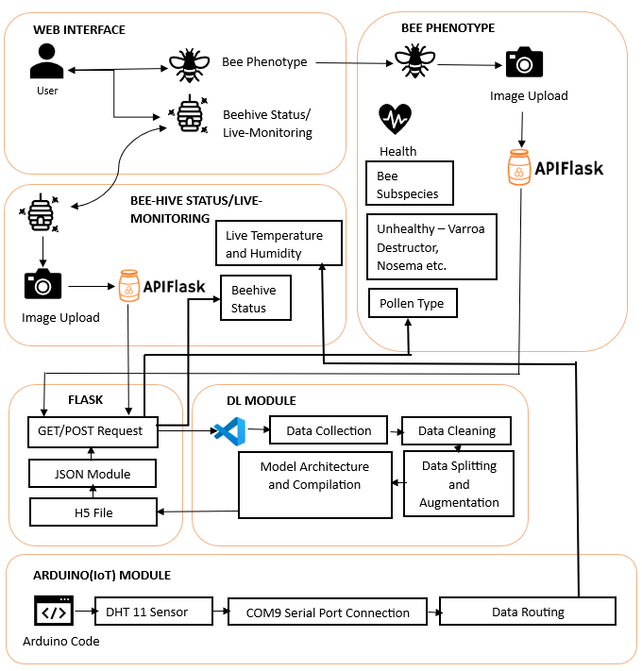

FIGURE 8: ARCHITECTURE DIAGRAM

While MobileNetV2 is well-suited for resource-constrained scenarios and image classification tasks, there might be specific cases where using a Sequential Model could offer advantages as the Sequential Model allows for greater customization of layers and architecture, making it more adaptable to specific requirements of the bee phenotype assessment task. Customizing the model architecture may be beneficial for fine-tuning the model to the unique features and nuances of bee images. As the dataset for bee phenotype classification is large and domain-specific, a Sequential Model can be trained from scratch or fine-tuned more effectively compared to a pre-trained MobileNetV2 and transfer learning using MobileNetV2 might not always be advantageous if the source domain (ImageNet) significantly differs from the target domain (bee images).

On training and testing the various model, The Sequential Model provides a clearer and more interpretable structure, making it easier to debug and understand the model's behavior during training and inference while the MobileNetV2's complex architecture may pose challenges in terms of interpretability, especially for users who require a detailed understanding of the model with the only demerit of the Sequential Model being the lack of computational resources [14].

While the project has made significant strides in technological innovation, there remain avenues for future enhancements. Further refinements in the deep learning model, exploration of additional environmental parameters, and integration of automated hive inspection mechanisms could contribute to the project's continuous evolution. Overall, this initiative holds the promise of advancing beekeeping practices, contributing to ecological sustainability, and fostering the well-being of vital pollinators.

##### **Acknowledgment**

This research endeavor was cultivated within the nurturing environment of SRM School of Computing, with profound appreciation for the invaluable guidance and mentorship provided by the esteemed triumvirate of knowledge and wisdom: Dr. Godfrey Winster S, Dr. Manoj Kumar Rana, Dr. Kandan M and Dr. Arulmurugan R.

##### References

1. Sarah Myers, 2020. 5 ways to measure beehive health with hive-streaming data. Availabe at: https://www.sas.com/en_in/insights/articles/big-data/measure-beehive-health-with-analytics.html
2. D. Braga, A. Madureira, F. Scotti, V. Piuri and A. Abraham, "An Intelligent Monitoring System for Assessing Bee Hive Health," in IEEE Access, vol. 9, pp. 89009-89019, 2021, doi: 10.1109/ACCESS.2021.3089538.
3. Duarte Cota, José Martins, Henrique Mamede, Frederico Branco,BHiveSense: An integrated information system architecture for sustainable remote monitoring and management of apiaries based on IoT and microservices,Journal of Open Innovation: Technology, Market, and Complexity,Volume 9, Issue 3,2023,100110,ISSN 2199-8531,https://doi.org/10.1016/j.joitmc.2023.100110.(<https://www.sciencedirect.com/science/article/pii/S2199853123002123>)
4. DAYIOĞLU, M. A., & TURKER, U. (2021). Digital Transformation for Sustainable Future - Agriculture 4.0: A review. Journal of Agricultural Sciences, 27(4), 373-399. <https://doi.org/10.15832/ankutbd.986431>
5. Asaduz Zaman, Alan Dorin,A framework for better sensor-based beehive health monitoring,Computers and Electronics in Agriculture,Volume 210,2023,107906,ISSN 0168-1699,https://doi.org/10.1016/j.compag.2023.107906.(https://www.sciencedirect.com/science/article/pii/S0168169923002946)
6. Fiona Edwards-Murphy, Michele Magno, Pádraig M. Whelan, John O’Halloran, Emanuel M. Popovici,b+WSN: Smart beehive with preliminary decision tree analysis for agriculture and honey bee health monitoring,Computers and Electronics in Agriculture,Volume 124,2016,Pages 211-219,ISSN 0168-1699,https://doi.org/10.1016/j.compag.2016.04.008.(<https://www.sciencedirect.com/science/article/pii/S0168169916301235>)
7. Maher Youssef Mohamed and Mohammed Shakir Mansor 2023 IOP Conf. Ser.: Earth Environ. Sci. 1158 032015Daisy THOMAS, N PAL, K SUBBA RAO , IEEE Conference on “Bee Management and Productivity of Indian Honeybees”, Oct 2021
8. Jenny Yang. June 2019. The BeeImage Dataset: Annotated Honey Bee Images Version 8.24 [10-01-2024]. https://www.kaggle.com/datasets/jenny18/honey-bee-annotated-images
9. William Kelley, Iren Valova, Douglas Bell, Ojonukpemi Ameh, Jacob Bader,Honey sources: neural network approach to bee species classification,Procedia Computer Science,Volume 192,2021,Pages 650-657,ISSN 1877-0509,https://doi.org/10.1016/j.procs.2021.08.067.(https://www.scienc
10. edirect.com/science/article/pii/S1877050921015544) A.R.W . on “ A Collection record on Bee-keeping in India The Honey-Bee; its Nature, Homes and Products”, (June 2020)
11. Aluri, Jacob Solomon Raju & Rao, Srungavarapu & Sri, Srithar. (1999). The Dammer Bee, Trigona and its pollination in the Indian Flora. Journal of Palynology. 35-36. 73-92.
12. Chaudhary, O.P.. (1997). Successful introduction of Italian honey bees, Apis mellifera L. in south India.. Journal of Insect Science. 10. 23-29. Muhammad Shakir Z, Mohd Rasdi, Salleh , IEEE Conference on “ Honeybees, Apis cerana colony performance in the non-protected and protected beehive methods in relation to climatic factors”, March 2022.
13. Danka, Robert & Harris, Jeffrey & Villa, José. (2011). Expression of Varroa Sensitive Hygiene (VSH) in Commercial VSH Honey Bees (Hymenoptera: Apidae). Journal of economic entomology. 104. 745-9. 10.1603/EC10401.
14. Qaddoura, Raneem & Al-Zoubi, Ala & Faris, Hossam & Almomani, Iman. (2021). A Multi-Layer Classification Approach for Intrusion Detection in IoT Networks Based on Deep Learning. Sensors (Basel, Switzerland). 21. 10.3390/s21092987.
15. Sandler, Mark & Howard, Andrew & Zhu, Menglong & Zhmoginov, Andrey & Chen, Liang-Chieh. (2018). MobileNetV2: Inverted Residuals and Linear Bottlenecks. 4510-4520. 10.1109/CVPR.2018.00474.

**IEEE conference templates contain guidance text for composing and formatting conference papers. Please ensure that all template text is removed from your conference paper prior to submission to the conference. Failure to remove template text from your paper may result in your paper not being published.**